**Picabia, Francis (1879-1953)**

A cavalier individualist, Francis Picabia became an internationally renowned avant-garde artist, spearheading Paris and New York Dada with his friend Marcel Duchamp and also contributing to Dada in Zurich and Barcelona. Picabia was a car enthusiast who embraced modernity, viewing the machine as a form expressive of the modern spirit from which he drew a new and revolutionary artistic idiom. Picabia drew also upon the tenets of the Puteaux Group and, upon arriving in New York to exhibit at the Armory Show in 1913, was lauded as a leading Cubist. He worked for a time in Orphic Cubism, a blend of Cubist, Futurist, and Fauvist themes and techniques to which he added ‘abstracted’ industrial and biomorphic forms. Although he maintained an interest in the figure, Picabia is known primarily for his early dialogue with abstraction and his development of a quasi-machine aesthetic. He looked to industrial diagrams for artistic inspiration and, upon returning to New York in 1915, during a period of involvement with photographer and modern arts patron Alfred Stieglitz’s famous 291 Gallery and journal, produced the famous *Mechanomorph* series. Depicting Stieglitz and his entourage as bizarre, seemingly dysfunctional, industrial forms, Picabia’s *Mechanomorphs* shaped the visual vocabulary of New York, and later Paris, Dada. Picabia’s ironic stance in relation to art and culture has prompted scholars to interpret his conflation of human and machine parts as also playful punning of morality, sexuality, and blind faith in technology.

Born in Paris in 1879 to a Spanish aristocrat with Cuban interests and a cultured, bourgeois Frenchwoman, François Marie Martinez (Francis) Picabia enjoyed the freedoms of affluence. From the age of seven, and the untimely death of his mother, Picabia was raised by his father and uncle, a conservator at the Bibliothèque Sainte Geneviève. His grandfather, a prominent photographer who knew Daguerre, was also an important figure in Picabia’s life. With the aid of his family, who hoped he would become an industrial designer, Picabia embarked on an education in drafting at the *École des Arts Décoratifs*, returning subsequently to studies in painting and his own independent work. He began exhibiting Impressionist landscapes (c. 1899) and worked through a variety of styles during the first decade of the twentieth century. He became involved with Duchamp (c. 1910) and the Puteaux Group of Cubists (1911), working for a time in his own blend of Cubist and Fauvist styles combined with biomorphic and machine forms. In 1912 he helped organize the Section d’Or, an exhibition highlighting the work of the Salon Cubists in Paris. Travelling to New York in 1913 to exhibit in the Armory Show, he met Stieglitz and became fascinated with American culture and technology. Using a war-time mission to obtain supplies in the Americas as a ruse, Picabia returned to New York in 1915, at which time he renewed his involvement with Stieglitz and began work on the *Mechanomorphs*. He reunited with Duchamp (also fleeing the war) and the two men became the figureheads of New York Dada. In 1917 Picabia traveled to Barcelona, where he published his first volume of poetry and the early editions of his journal *391* (honoring Stieglitz’s 291). Picabia collaborated with Tristan Tzara of Zurich Dada in 1918 and, along with Duchamp and others, helped found Paris Dada in 1919. Rejecting collective dogmatism, Picabia broke with Dada publically in 1921, just as he would break his loose affiliation with André Breton’s Surrealism in 1924. During the interwar period, Picabia developed a more abstracted machine vocabulary, working virtually simultaneously in classical figuration. He subsequently produced his *Monster* and *Transparency* series, paintings demonstrating his continued figural engagement, here incorporating Surrealist elements. Picabia lived periodically in the south of France and during WWII produced paintings there drawn from erotic magazines. A staunch nonconformist, Picabia worked in a variety of artistic styles throughout his long and prolific career.

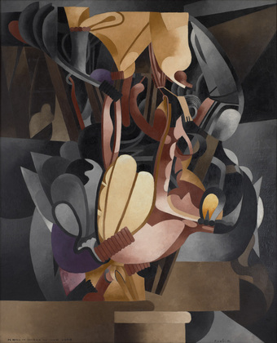

Francis Picabia, *I Still See in Memory My Beloved Udnie*., 1914 (possibly begun 1913). Oil on canvas, 8' 2 1/2" x 6' 6 1/4" (250.2 x 198.8 cm), MoMA.

<http://www.moma.org/collection/provenance/provenance_object.php?object_id=78348>

[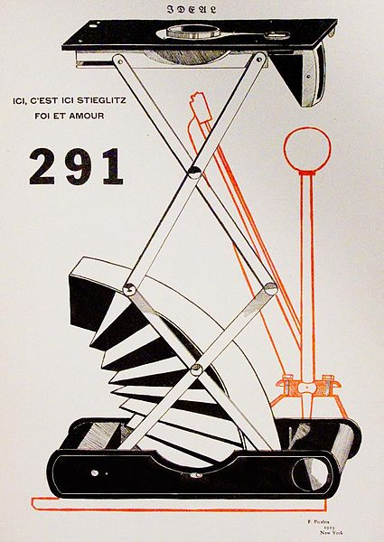](http://upload.wikimedia.org/wikipedia/commons/e/ee/291-No1Cover.jpg)

Francis Picabia, *Ici, c'est ici Stieglitz, foi et amour*, Mechanomorph, Cover of 291, No1, 1915, public domain.

References and further reading:

Antliff, A. (2001) “Egoist Cyborgs.” In *The Uncanny: Experiments in Cyborg Culture*, ed. Bruce Grenville, 101-113. Vancouver, B.C.: Vancouver Art Gallery.

Baker, G (2010) *The Artwork caught by the Tail*. Cambridge, Mass: MIT Press.

Borràs, M. (1985) *Picabia*. New York: Rizzoli.

Camfield, W. (1972) *Francis Picabia*. New York: Solomon R. Guggenheim Museum.

Camfield, W. (1966) “The Machinist Style of Francis Picabia.” *Art Bulletin* XLVIII: 309-322.

Picabia, F. (1913) Statement made to the New York Times, 16th February: Picabia Art Rebel, Here to Present the New Movement, Section V, p. 9.

Picabia, F. (1915) Statement to the New York Tribune, 24th October: French Artists Spur on American Art, Section IV, p. 2.

Zdenek F. (1998) *Francis Picabia: The Late Works 1933-1953*. Ostfildern-Ruit: Hatje.

Suggested Images:

*I See Again in Memory My Dear Udnie*, 1914 (possibly begun 1913), oil on canvas, 8' 2 1/2" x 6' 6 1/4" (250.2 x 198.8 cm), MoMA, New York.

<http://www.moma.org/collection/provenance/provenance_object.php?object_id=78348>

Francis Picabia, *Ici, c'est ici Stieglitz, foi et amour*, Mechanomorph, Cover of 291, No1, 1915, public domain.